Debugging betmte v2, when you click a log selection in afl it has this glitchy effect makes it imossible to place bets, Lets make the log singe and cancel more prominent, either same as add to betslip or something ifferent than the background at least, even if they just cange when you hhover.
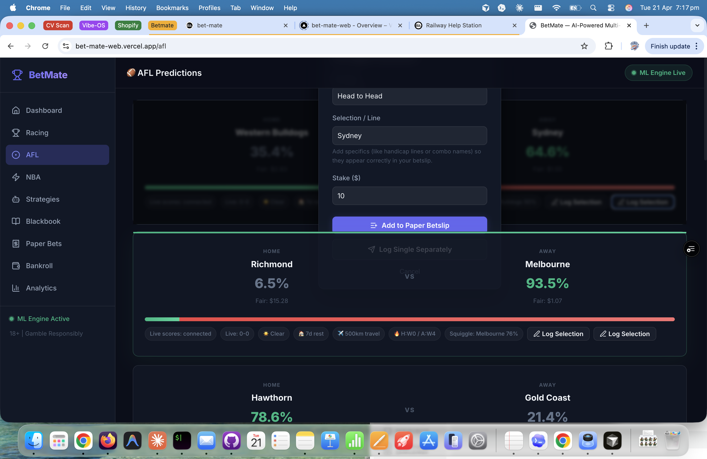
When you log selections the paperbetslip comes up, I want it to stay minimimzed, the bet goes to slip but it stays low and only comes up for them to check it
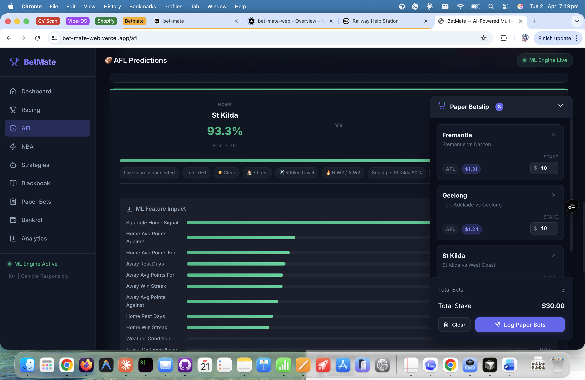
The first log selection needs to be under the home team so should be log selection home,then all the things in middle then log selection away. This needs to be the same for racing and nba.


Logo needs to look like this


And we need to include betmate bob in the ask bob section as well as somewhere on the homepage maybe below the menu

Need to place paper bets om all aussie races most aren’t even displaying they don’t need predictions but should be able to place bets on all. I think it should have racing predictions, and list predictions for the main races – melb Sydney WA/bris where relevant. They should stay there unitl they update the next day so people that look at night can see what the ML did and you need to be able to copy them straight to betslip. Below that should be race listings for al races and the ability to place paper bets.
